Behaviour 2 Tutorial

This tutorial will show you how to spawn an object with a little lunge force. This could be used for UI as damage, when a character jumps out of a teleporter etc.

**Step 1: Create a floor using a 3D cube, a sphere and an empty object called spawn point. The empty object is where our sphere will be spawn in, position the spawn point above the floor.**

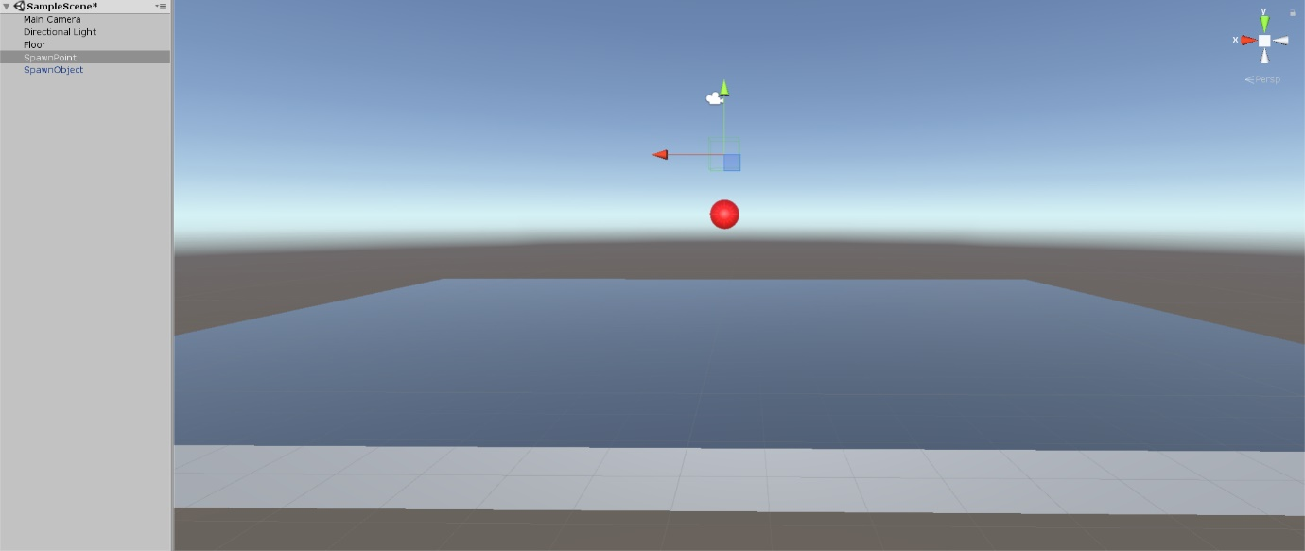

**Step 2: Click and drag the sphere from the hierarchy into our assets folder. This will create a pre-fab, this pre-fab will be used in the script so it knows what object to spawn. You can now delete sphere from the hierarchy as we don’t need it anymore.**

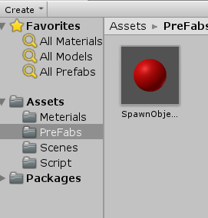

**Step 3: Create a C# script and call it spawn. Click and drag the spawn script into the spawn point on your hierarchy.**

**Step 4: Add a Rigidbody component to our sphere by going into the spheres inspector and add component.**

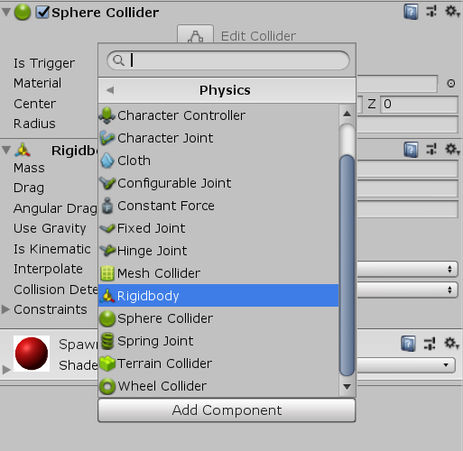

**Step 5: Open your script in either MonoDevelop or Visual studio.**

**We will need to declare 4 variables.**

**Public GameObject spawnObject; `this is where we will reference the object we are spawning.**

**Public float jumpForce; `this will determine how much force we will apply to the lunge.**

**Rigidbody rb; `this will be used to store the attributes of our spawn object, so we can manipulate it by adding force.**

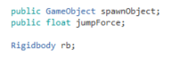

**Step 6:**

**We don’t need the void Start so we can just delete or ignore that.**

**Under void Update, we will have the code that will detect the key player pressed, spawning the object and adding force to that object to make it lunge.**

void Update () {  
        if (Input.GetKeyDown(KeyCode.Space)) { ``when the player pressed the space bar   
            GameObject temp = Instantiate (spawnObject, transform.position, Quaternion.identity); ``here we create a game object variable called temp, this will store the information of the object spawned. Once another object spawn, the values inside temp will be replaced by the new object we spawned. The second half spawns the object in the same location as the object we attached to, in this case it’s the spawn point.  
  
            rb = temp.GetComponent<Rigidbody>(); ``the variable gets the rigidbody component from the object we just spawned.  
            rb.velocity = new Vector3 (rb.velocity.y, jumpForce, rb.velocity.z); ``this will add velocity to the x axis of our object by the amount we set as jumpForce, this will make the spawned object lunge upward, if you want to add velocity to the left or right of the object, replace the y or z axis with jumpForce.  
        }  
    }

**Step 7:**

**Click and drag the pre-fab you created into Spawn Object and set the jump force you want.**

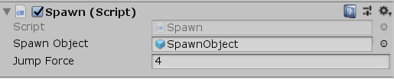

**Step 8:**

**Press the play button. Now every time you press down the space bar, you should spawn a sphere with a little lunge upward. Experiment with the jump force to get it to your liking.**

